System Process
The webMIP system handles on-line meter related works and services quotations for their customers: Gas Suppliers and their Agents. Agents submit enquiries for the required works; and webMIP, where possible, provides one or more quotations that match the scope of works.
In addition to the quotation aspects of the system, webMIP provides functions to administer the system.
This section of the document describes the processes and tasks performed by the webMIP system. It details the processes from the initiation of an enquiry to the final quotation and briefly describes some of the processes required to administer the system. The limitations and constraints placed upon these tasks and processes is described previously in the Scope section of this document.
Illustration 1: System Process Map - Slide 1
Illustration 2: System Process Map - Slide 2
Illustration 3: System Process Map - Slide 3
Illustration 4: System Process Map - Slide 4

Quotation Processes
The process of quotation will always be driven by the supplier agents. webMIP is to provide a quick and easy interface for agents to request a quotation. Not all agents will use webMIP; and for quotations that require manual intervention from the D&Q team, a separate interface will be provided to the D&Q team to allow them to upload manual created bespoke quotes. There are 3 main stages to the quote process, Enquiry, Quote and Job.
- Enquiry, where the user fills in a questionnaire, provides data relating to the meter, the meter site, and environment.
- Quote, if the enquiry is submitted then a quote is generated detailing the costs of the specified meter and any add-ons.
- Job, if a quote is accepted by the user then the quote turns into a Job, at this point the job is outside the scope of webMIP functionality.

Initial Enquiries
A request for quotation can take many different forms, agents will phone, fax, email or post a request for quote. With the introduction of webMIP the agents will now also be able to request for quote via the internet directly into webMIP. Irrespective of the method of initiation all enquiries will be stored within the webMIP system. When members of I&C receive a request that is not received via the internet(webMIP) then the details of the enquiry will be entered onto the webMIP system by a member of the I&C team. To start an enquiry the users must choose a job type. If the user is a member of the I&C team then the agent details will also need to be selected. When a job type is selected an enquiry reference number is generated by the system. The users can then reference and edit previously created enquiries via the enquiry reference number, transaction reference, post code or MPRN of an enquiry. Agent users will only be able to search for enquiries within their supplier grouping.
Agents and I&C users will be able to copy previously created enquiries. When the enquiry is copied only the data entry is copied,(no uploaded files), the current Agents details are selected (or need to be selected for I&C users) and a new enquiry reference number will be generated. Whenever a enquiry is copied or edited the user is always placed at the start of the questionnaire.

Enquiry Data
In order for webMIP to provide an automated quotation certain data must be entered into the system, not all combinations of data can result in an automatic quote. In cases where an automatic quote cannot be provided the D&Q team will build a manual quote.
The complete list of enquiry data items are described in Appendix A.
The data required for the enquiry can be split into the following areas :-

Supplier and agent details
The supplier and agent details are required so that quote related information can be delivered to the correct supplier/agent and to the correct addresses. The Supplier and agent details are saved in the system and can be recalled or referenced and used again by the webMIP system. When an agent starts a new enquiry the system will automatically determine the agent from their login authentication. This means that the agents/suppliers will only need to supply this information once, see the system administration for further information. Each gas supplier can have many agents and each agent must have an associated gas supplier.

Gas Supplier

Supplier Agent
The user will have the option of selecting their preferred contact mechanism, e.g. phone, fax or email. The user will only be able to select one option, the option they select must have an valid value in the associated data item.

Job Site Details
The job site details relate to the address at which the works will be completed. This will include the address, contacts and Network related information. Each enquiry must have just one associated set of site details. Once the site details are submitted the system will store them for reference so that the agent or I&C user can recall them at a later date.
***Need to have a field for the D&Q users to select the Agent by, so that they can fill in the questionnaire on behalf of the Agent

Job Information
The job information section records data relating to the job requirements including meter requirements and the meters environment. Like the job site details, once the job information details are submitted they are stored by the system so that the agent or I&C users can then refer back to them. Each enquiry must have just one associated set of job information.

Enquiry Flow Chart
The following shows the overfall flow of the enquiry questions:
Illustration 5: Questionnaire Flow Chart - Slide 1
Illustration 6: Questionnaire Flow Chart- Slide 2
Illustration 7: Questionnaire Flow Chart - Slide 3
Illustration 8: Questionnaire Flow Chart - Slide 4

Manual(bespoke) or Automatic(standard)
At this point webMIP will decide which path the quotation will take. If the job is within the scope of an automatic(standard) quote then webMIP will present a list of modules for the user to select. If the system cannot provide a automatic quote then webMIP will determine the job to be a manual(bespoke) job, it will then send an email to D&Q team to inform them that a manual quote is required, see the communication section for further information.
The system will determine a quote as non-standard or manual(bespoke) by determining the service pressure, metering pressure and Qmax. The system also considers whether the job requires a bypass, twin stream or site survey. The determination can be seen using the following rules :-
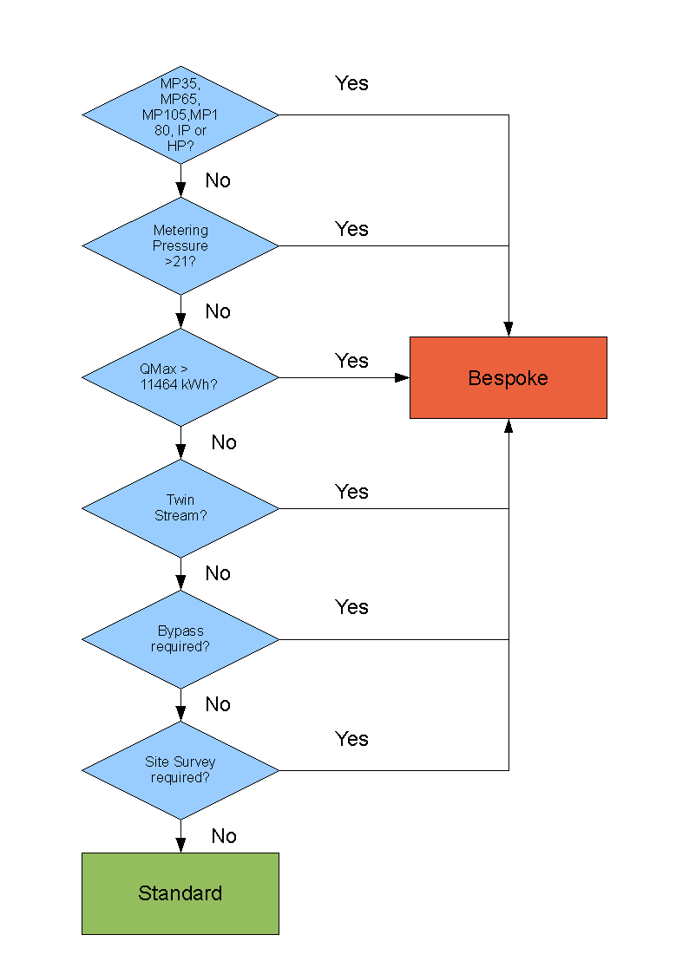
The site survey

The following standard LP jobs will require a site survey :-
- Relocation
- Exchange where upgrade is greater than one size ie 16 up to 40,

Meter Selection
If the user has selected *** a standard job type then as long as the values they submitted are within the scope of a valid standard job then the system will provide a list of selectable modules.
Meter modules are selected using the following enquiry details:
- Inlet Pressure;
- Inlet Orientation;
- Outlet Pressure;
- Qmax;
Each meter module is associated with a single housing and this will be selected if the enquiry requests it.
Each meter module is associated with a single base and this will be selected if the enquiry requests it.
Once the webMIP system has determined that an enquiry can be provided with a standard quote the following items of data will be provided with each of the meters listed :-
- Meter module name – The name/description of the meter module
- Module cost – the cost to the agent for the individual module
- Base cost – The cost of the base to the agent
- Housing cost – The cost of the housing (if the user selected one)
- Total cost – To total cost of the module and the chosen add-ons
- Rental cost – The rental cost of the module?
- Contract Lead time – The number of days that the job must be completed with (after quote acceptance)
- Qmax – The Qmax value for the module, in Kwh
- Housing size – The size of the housing required for the module
- Inlet orientation – The orientation of the inlet pipework
- Outlet orientation – The orientation of the outlet pipework
Once the appropriate meter is selected a more detailed description of the module and the appropriate add-ons is provided by the system. The user has the option to choose a different module at this stage if they require. Selecting a different module will display the detailed display for that module. The user will be able to submit for a quotation at this stage. The data items provided for the detailed display are as follows:-
- Module name – The name of the module
- Qmax – The Qmax value for the module, in Kwh
- Qmin – The Qmin value for the module, in Kwh
- Service Pressure – The service pressure category for the module (eg. LP)
- Meter Pressure – The meter pressure, mbar (eg. 21)
- Module Lead Time – The number of days that the job must be completed with (after quote acceptance)
- Dimensions – The Width, depth and height of the module, in mm
- Weight – The weight of the module, in kg
- Inlet – The inlet orientation configuration
- Outlet – The outlet orientation configuration
- Module Cost – The cost of the module
- PM Rental – The cost to rent the module per month
In additional list of selected module add-ons is provided with the following data items displayed for each add-on :-
- Accessory – The name of the add-on
- Cost – The cost of the add-on
- Lead time – The lead time (if appropriate) for delivering/fitting the add-on
- Dimensions – The width, depth and height of the add-on
- Weight – The weight of the add-on in kg
- PM Rental – The cost to rent the add-on per month
There is an additional total line for the list of add-ons, that totals the collective costs of the add-ons.
At this stage the user has the option to submit for quotation or to *** (if still in scope) save/store the enquiry and return to it at a later stage.

The Quotation
Once the user has submitted the questionnaire the enquiry aspect of the system is finished and the system now moves into the quotation stage. What happens at the quotation stage depends on what the user specified within the questionnaire. If the user selected a non-standard job type or a standard job has fallen out of scope then the system will inform the user that a manual or bespoke quote will be provided within. Enquiries that are within the scope of a standard job will provide the user with an automatic quote produced from within the system.

Email
At the quotation stage the system communicates either directly to the agent user and/or the I&C team. The method depends on the type of quote. Automatic quotes will cause the system to send an email the user with the quote details, I&C will receive an email if the user did not specify email as their preferred method of communication. Bespoke quotes will cause the system to send an email the user informing them the quote has gone 'bespoke' and cannot be quoted automatically, I&C will receive an email informing them of a new bespoke quote. See the Communication section in this document for further information. When I&C receive the email they can then build the bespoke quote, once complete the bespoke quote is uploaded to the webMIP system, and the agent user can view the uploaded quote. It is expected that the I&C user will then email the agent (if required) to inform them that the quote is ready for acceptance/rejection and possible also include a copy of the bespoke quote details. The user can then accept/reject the quote in the same way as an automatic quote.

Quote Data
Once the user has requested a quotation and the enquiry is a valid standard job. The system will provide the user with a formal quotation. The user is unable to change any detail of the quote at this stage. However the following data items are provided to help the user decide whether to accept the quote or not.

Automatic Quotes
The items provided are listed as follows :-
- Quote Reference Number – The unique number associated with the quote, one quote reference number is generated for each quote. Every quote in the system must have a quote reference number. The quote reference number is generated when the user submits the enquiry for quotation and the enquiry data submitted passes the validation criteria.
- Meter details – A standard technical drawing that details the dimensions and technical specifications of the meter module, including measurements.
- Base details – A standard technical drawing detailing the dimensions of the module base
- Housing details – A standard technical drawing that details the dimensions of the housing unit.
- Service Termination? ***
- Hazardous Area Drawing ?***
- Site Address – The address that the works are to be completed.
- Cost Summary – Costs of the selected module and associated add-ons.
- Quote as PDF – The option to view the quote as a PDF document.

Bespoke Quotes
The data provided for a bespoke quote will be the contents of the uploaded file from I&C, webMIP will not provide any further information other than the quote reference number and a link to the uploaded file.

Quote Acceptance/Rejection
Once the quote is formally presented to the user, the system should provide the user with the option to accept or reject the quote. The quote does not need to be accepted or rejected immediately, once created the quote will be valid for 90 days, starting from when the quote was created on the system. Quotes that elapse the ***90 days will no longer be accessible to the agent users on the system. For agents that do not have access to the webMIP system, quotes will be accepted or rejected on their behalf by one of the I&C users, the I&C user that created the quote will be unable to accept or reject the quote. The system will record the name of the I&C User that accepted or rejected the quote.

Accepted Quotes
***What will be in a standard quote? Data items etc. header/footer detail, other text etc.
If the user accepts the quote then the system performs the following functions :-
- Emails I&C a PDF of the final quote and a link to the quote on the webMIP system to inform them that a quote has been accepted. The system will email one of two different mailboxes, one for automatic quotes and one for manual(bespoke) quotes, see the Communication section of this document for further information.
- TBC Builds a CSV file and sends it to a specified mail box so that the SAP Blueprint system can gain the relevant information to start the works. Bespoke quotations will not generate a CSV file, it is envisaged that I&C will input the data into the Blueprint system.
- If the agents user preferences are specified to receive email, webMIP system will send an email to the agent with a PDF of the final quote and a link to the quote on the webMIP system. See the Communication section of this document for further information.
- Provides the user with a list of possible forms that need filling in or what to do next.

Rejected Quotes
If the quote is rejected by the user then the system will mark the quote as rejected. The system will then request the user to enter a reason for the rejection. The user can select a reason from a list of the following options :-
- ,
- Too expensive?
The user will also have the option to enter the reason in an alphanumeric data item of 250 characters. Once the reason for the rejection is recorded the system will return the user to the initial start page of the system.

***(might need to revise the next sentence)
***(need to draw a similar flow chart or do we? (see question 23 an d 24) how do we determine the site survey? (we only consider LP and I'm assuming that all modules are diaphragm as anything else will be bespoke anyway)
***(question 12, should really define the scope for each of the standard job types)
***(Question20)
*** would need to define what measurements.
***(question 17)
***(Could de-scope the following to save costs)
-The following could be de-scoped***
***See the Reports section of this document for further information.
(*** Question 21, DH to specify)
***(Question 18, DH to provide drop down list of options)
***Does the system need to email anyone to say the quote has been rejected?

