System Process
This section of the document describes the processes and tasks performed by the webMIP system. It details the processes from the initiation of an enquiry to the final quotation and briefly describes some of the processes required to administer the system. The limitations and constraints placed upon these tasks and processes is described previously in the Scope section of this document.

Quotation Processes
The quotation process is driven by the supplier agents. There are three main stages to the quote process:
- Enquiry. The user fills in a questionnaire, providing data relating to the meter, the meter site, and environment.
- Quote generation. If the enquiry is submitted then a quote is generated detailing the costs of the specified meter and any add-ons.
- Quote acceptance, if a quote is accepted by the user then the quote turns into a Job, at this point the job is outside the scope of webMIP functionality.
The webMIP system provides a quick and easy interface for agents to request a quotation on-line. Agents may also phone, fax, email or post a request for a quote; in these cases the enquiry is entered into webMIP by an I&C User on behalf of the agent.
The user logs into the system using a user name and password combination. The user name is associated with the supplier on whose behalf they perform work. If the user is a member of the I&C team then the user will select the user name of the agent on whose behalf they are entering the enquiry information.

Enquiry
The system allows the user to perform the following primary functions:
- Create a new enquiry;
- Amend an existing enquiry;
- Copy an existing enquiry to create a new enquiry.
The complete list of enquiry data items are described in Appendix A.

Create a new enquiry
The system generates and records a unique enquiry reference for the new enquiry. The system records supplier-related information against the new enquiry by referring to the user agent details to find the supplier on whose behalf the user performs work. The system records the user details against the enquiry.
The user enters site location information and then fills in the questionnaire.
The questionnaire is presented as a series of questions (either grouped or singular) on a succession of screens. The system records the answers to questions when the user completes a screen. The system alters the 'flow' of questions depending on the answers given to previous questions. Each question may have associated 'help' associated with it that is presented to the user on request. The user is able to exit from the questionnaire before all the questions have been answered: the user may choose to amend or complete the enquiry at a later date.
When the questionnaire is completed, the user is able to request a quote.

Amend an existing enquiry
The user searches for existing enquiries using the unique enquiry reference, transaction reference, post code or MPRN of an enquiry. The system limits the enquiries that can be queried to those associated with supplier on whose behalf the user performs work: the queried enquiries may have been created by other users. If the enquiry has not been marked as 'quoted for', the user is able to amend the enquiry.
The user may amend the site location information, completed questions from the questionnaire or complete unanswered questions.
When the questionnaire is completed, the user is able to request a quote.

Copy an existing enquiry to create a new enquiry
The user searches for existing enquiries using the unique enquiry reference, transaction reference, post code or MPRN of an enquiry. The system limits the enquiries that can be queried to those associated with supplier on whose behalf the user performs work: the queried enquiries may have been created by other users. If the enquiry has not been marked as 'quoted for', the user is able to amend the enquiry.
The system allows Agents and I&C users to create a new enquiry by selecting an existing enquiry and copying the details of that enquiry. The system amends the new enquiry by applying the current Agents details and removing any files associated with the original enquiry.
The user is able to amend the new enquiry.

Quote generation
The system generates quote(s) on request against enquiries that have not already been marked as 'quoted for'. There are two methods of quote generation:
- Automatic quotation. The system produces a quote without manual intervention;
- Manual quotation. The system is unable to automatically produce a quote and relies on a manual process to produce the quotation off line.

Automatic quotation
The quotations are based on selecting meter modules that match the enquiry requirements.
Meter modules are selected using the following enquiry details:
- Inlet Pressure;
- Inlet Orientation;
- Outlet Pressure;
- Qmax;
Each meter module is associated with a single housing and this will be selected if the enquiry requests it.
Each meter module is associated with a single base and this will be selected if the enquiry requests it.
The system produces a quote for each selected meter module. The following items of data will be provided with each of the meter modules listed:
- Meter module name – The name/description of the meter module
- Module cost – the cost to the agent for the individual module
- Base cost – The cost of the base to the agent
- Housing cost – The cost of the housing (if the user selected one)
- Total cost – To total cost of the module and the chosen add-ons
- Rental cost – The rental cost of the module?
- Contract Lead time – The number of days that the job must be completed with (after quote acceptance)
- Qmax – The Qmax value for the module, in KWh
- Housing size – The size of the housing required for the module
- Inlet orientation – The orientation of the inlet pipework
- Outlet orientation – The orientation of the outlet pipework
The system also produces a more detailed report document containing a description of the module and the appropriate add-ons. The detailed report document contains the following data items:
- Module name – The name of the module
- Qmax – The Qmax value for the module, in Kwh
- Qmin – The Qmin value for the module, in Kwh
- Service Pressure – The service pressure category for the module (eg. LP)
- Meter Pressure – The meter pressure, mbar (eg. 21)
- Module Lead Time – The number of days that the job must be completed with (after quote acceptance)
- Dimensions – The Width, depth and height of the module, in mm
- Weight – The weight of the module, in kg
- Inlet – The inlet orientation configuration
- Outlet – The outlet orientation configuration
- Module Cost – The cost of the module
- PM Rental – The cost to rent the module per month
An additional list of selected module add-ons is provided with the following data items displayed for each add-on:
- Accessory – The name of the add-on
- Cost – The cost of the add-on
- Lead time – The lead time (if appropriate) for delivering/fitting the add-on
- Dimensions – The width, depth and height of the add-on
- Weight – The weight of the add-on in kg
- PM Rental – The cost to rent the add-on per month
There is an additional total line for the list of add-ons, that totals the collective costs of the add-ons.

Manual quote generation
Where the system is unable to produce a quotation, the system supports a manual process of uploading a quotation document generated off-line and making it available to the user. The system has no knowledge of the contents of the manual quotation.

Quote acceptance
The user searches for existing enquiries using the unique enquiry reference, transaction reference, post code or MPRN of an enquiry. The system limits the enquiries that can be queried to those associated with supplier on whose behalf the user performs work: the queried enquiries may have been created by other users. If the enquiry has been marked as 'quoted for' and the quotations have not lapsed or the enquiry has been marked as 'complete' the user is able to view associated quote(s).
The user is able to select a quote and view the detailed report.
The user rejects quotes by selecting from the list and choosing the 'reject' option. The user is asked to enter a reason for the rejection. A rejected quote cannot be subsequently accepted. The system marks the enquiry as 'complete' if all quotes have been rejected.
The user accepts a quote by selecting from the list and choosing the 'accept' option. The system records the details of the user against the enquiry. The system marks the enquiry as 'complete'. An accepted quote cannot be subsequently rejected. An enquiry cannot have more than one accepted quote. The system uses email to contact the I&C department with details of the accepted quote.

System Process Map
The following chart shows the overall flow of the Quotation Processes.
Illustration 1: System Process Map - Slide 1

Illustration 2: System Process Map - Slide 2
Illustration 3: System Process Map - Slide 3
Illustration 4: System Process Map - Slide 4

Enquiry Flow Chart
The following shows the overall flow of the enquiry questions
Illustration 5: Questionnaire Flow Chart - Slide 1
Illustration 6: Questionnaire Flow Chart - Slide 2
Illustration 7: Questionnaire Flow Chart - Slide 3
Illustration 8: Questionnaire Flow Chart - Slide 4

Manual(bespoke) or Automatic(standard)
At this point webMIP will decide which path the quotation will take. If the job is within the scope of an automatic(standard) quote then webMIP will present a list of modules for the user to select. If the system cannot provide a automatic quote then webMIP will determine the job to be a manual(bespoke) job, it will then send an email to D&Q team to inform them that a manual quote is required, see the communication section for further information.
The system will determine a quote as non-standard or manual(bespoke) by determining the service pressure, metering pressure and Qmax. The system also considers whether the job requires a bypass, twin stream or site survey. The determination can be seen using the following rules :-
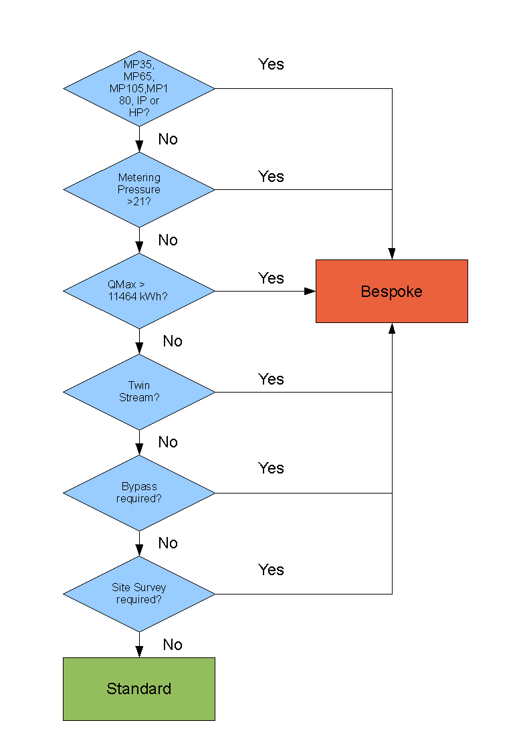
The following standard LP jobs will require a site survey :-
- Relocation
- Exchange where upgrade is greater than one size ie 16 up to 40,

Meter Selection
If the user has selected *** a standard job type then as long as the values they submitted are within the scope of a valid standard job then the system will provide a list of selectable modules.

The Quotation
Once the user has submitted the questionnaire the enquiry aspect of the system is finished and the system now moves into the quotation stage. What happens at the quotation stage depends on what the user specified within the questionnaire. If the user selected a non-standard job type or a standard job has fallen out of scope then the system will inform the user that a manual or bespoke quote will be provided within. Enquiries that are within the scope of a standard job will provide the user with an automatic quote produced from within the system.

Email
At the quotation stage the system communicates either directly to the agent user and/or the I&C team. The method depends on the type of quote. Automatic quotes will cause the system to send an email the user with the quote details, I&C will receive an email if the user did not specify email as their preferred method of communication. Bespoke quotes will cause the system to send an email the user informing them the quote has gone 'bespoke' and cannot be quoted automatically, I&C will receive an email informing them of a new bespoke quote. See the Communication section in this document for further information. When I&C receive the email they can then build the bespoke quote, once complete the bespoke quote is uploaded to the webMIP system, and the agent user can view the uploaded quote. It is expected that the I&C user will then email the agent (if required) to inform them that the quote is ready for acceptance/rejection and possible also include a copy of the bespoke quote details. The user can then accept/reject the quote in the same way as an automatic quote.

Quote Data
Once the user has requested a quotation and the enquiry is a valid standard job. The system will provide the user with a formal quotation. The user is unable to change any detail of the quote at this stage. However the following data items are provided to help the user decide whether to accept the quote or not.

Automatic Quotes
The items provided are listed as follows :-
- Quote Reference Number – The unique number associated with the quote, one quote reference number is generated for each quote. Every quote in the system must have a quote reference number. The quote reference number is generated when the user submits the enquiry for quotation and the enquiry data submitted passes the validation criteria.
- Meter details – A standard technical drawing that details the dimensions and technical specifications of the meter module, including measurements.
- Base details – A standard technical drawing detailing the dimensions of the module base
- Housing details – A standard technical drawing that details the dimensions of the housing unit.
- Service Termination? ***
- Hazardous Area Drawing ?***
- Site Address – The address that the works are to be completed.
- Cost Summary – Costs of the selected module and associated add-ons.
- Quote as PDF – The option to view the quote as a PDF document.

Bespoke Quotes
The data provided for a bespoke quote will be the contents of the uploaded file from I&C, webMIP will not provide any further information other than the quote reference number and a link to the uploaded file.

Quote Acceptance/Rejection
Once the quote is formally presented to the user, the system should provide the user with the option to accept or reject the quote. The quote does not need to be accepted or rejected immediately, once created the quote will be valid for 90 days, starting from when the quote was created on the system. Quotes that elapse the ***90 days will no longer be accessible to the agent users on the system. For agents that do not have access to the webMIP system, quotes will be accepted or rejected on their behalf by one of the I&C users, the I&C user that created the quote will be unable to accept or reject the quote. The system will record the name of the I&C User that accepted or rejected the quote.

Accepted Quotes
***What will be in a standard quote? Data items etc. header/footer detail, other text etc.
If the user accepts the quote then the system performs the following functions :-
- Emails I&C a PDF of the final quote and a link to the quote on the webMIP system to inform them that a quote has been accepted. The system will email one of two different mailboxes, one for automatic quotes and one for manual(bespoke) quotes, see the Communication section of this document for further information.
- TBC Builds a CSV file and sends it to a specified mail box so that the SAP Blueprint system can gain the relevant information to start the works. Bespoke quotations will not generate a CSV file, it is envisaged that I&C will input the data into the Blueprint system.
- If the agents user preferences are specified to receive email, webMIP system will send an email to the agent with a PDF of the final quote and a link to the quote on the webMIP system. See the Communication section of this document for further information.
- Provides the user with a list of possible forms that need filling in or what to do next.

Rejected Quotes
If the quote is rejected by the user then the system will mark the quote as rejected. The system will then request the user to enter a reason for the rejection. The user can select a reason from a list of the following options :-
- ,
- Too expensive?
The user will also have the option to enter the reason in an alphanumeric data item of 250 characters. Once the reason for the rejection is recorded the system will return the user to the initial start page of the system.

Orientation was taken out of the questionnaire as all modules were provided with all the pipework that they supported. However, the MIP5 modules selection query specifically checks the inlet orientation. Presumably this is because not all modules support all inlet orientations?
Need to confirm the information sent by the system.
***(need to draw a similar flow chart or do we? (see question 23 an d 24) how do we determine the site survey? (we only consider LP and I'm assuming that all modules are diaphragm as anything else will be bespoke anyway)
***(question 12, should really define the scope for each of the standard job types)
***(Question20)
*** would need to define what measurements.
***(question 17)
***(Could de-scope the following to save costs)
-The following could be de-scoped***
***See the Reports section of this document for further information.
(*** Question 21, DH to specify)
***(Question 18, DH to provide drop down list of options)
***Does the system need to email anyone to say the quote has been rejected?

